Converting counts from excel to the datastandaard database using the API

# Goal

Once the counting sheet for a Survey has been downloaded, the counting starts.

There are 2 different kinds of counting:

1. Capacity counts: how many parking places are there in a Section?
2. Occupation counts: how many bikes are there actually parked in a Section?

Both figures can be filled in in the counting sheet, like this:



This sheet will be uploaded into the tool. For each row 2 separate api POSTs are generated:

One post for the capacity (dark cells)

One post for the occupation (light and blue cells)

The same endpoint is used for both measurements:

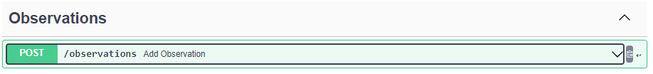

# Capacity measurement

POST /observations

{

"survey": "2BFC7794-C12E-4124-88FE-49F06F6FC166", // column ‘survey_id’

"observedProperty": "capacity",

"featureOfInterest": "B92170C7-4A23-462C-99AA-F3E090BCB045", // column ‘section_id’

"timestampStart": "2022-11-13T12:00:00", // column ‘observation_capacity_timestamp_start’

"timestampEnd": "2022-01-13T15:00:00", // column ‘observation_capacity_timestamp_end’

"measurement": {

"parkingCapacity": 0 // column ‘observation_capacity_parkingCapacity’

},

"note": { // optional, only if data is present

"remark": "Rainy day" // column ‘observation_capacity_note’

}

}

# Occupation measurement



{

"survey": "2BFC7794-C12E-4124-88FE-49F06F6FC166", // column ‘survey_id’

"observedProperty": "occupation",

"featureOfInterest": "B92170C7-4A23-462C-99AA-F3E090BCB045", // column ‘section_id’

"timestampStart": "2022-11-13T12:00:00", // column ‘observation_occupation_timestamp_start’

"timestampEnd": "2022-01-13T15:00:00", // column ‘observation_occupation_timestamp_end’

"measurement": {

"totalParked": 15, // column ‘observation_occupation_parkingCapacity’

"vehicleTypeCounts": [

// an item for every filled column from Y until end (= every Canonical Vehicle Type)

{

"canonicalVehicleCode": "A",

"numberOfVehicles": 4

},

{

"canonicalVehicleCode": "B",

"numberOfVehicles": 2

},

{

"canonicalVehicleCode": "Z",

"numberOfVehicles": 9

}

]

},

"note": { // optional, only if data is present

"remark": "Rainy day" // column ‘observation_occupation_note’

}

}